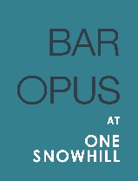
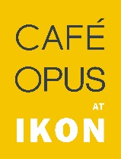

CANAPE LIST SPRING SUMMER 2016

£2.50 per piece
Please choose from the following list.
We are happy to recommend the number of canapes
for your guests appropriate to the style of your function.

HOT

Lollipop
Whole wild scallop wrapped in Parma ham

Fish’n’chips
Monkfish scampi in lemon and herb crumb, chunky tartare sauce, fat chips

Chorizo
Baby chorizo glazed with honey and thyme

Oyster
Crispy fried Carlingford rock oyster, citrus mayonnaise served in shell

Croquette
Smoked haddock and leek croquette, soft boiled quail’s egg
Lamb
Minted fillets of new season lamb

Filo (v)
Blue cheese filo parcel, pecan and poached pear

Tart (v)
Feta and tomato tartlets, rocket pesto

Pakora (v)
Carrot pakora, lentil dahl, mint yoghurt

Choux (v)
Savoury choux pastry, cream cheese

Fritter (v)
Thyme and potato dauphine, chive creme fraiche

COLD

Scone (v)
Mini chive scone, chilli jam

Smoked Mackerel
Smoked mackerel pate, lime and ginger mayo, caraway cracker

Macaron (v)
Curried cauliflower macaron

Focaccia (v)
Toasted focaccia, tomato jam, boconcini mozzarella

0121 200 2323 | www.opusrestaurant.co.uk | private rooms@opusrestaurant.co.uk

