`

BOOKING FORM

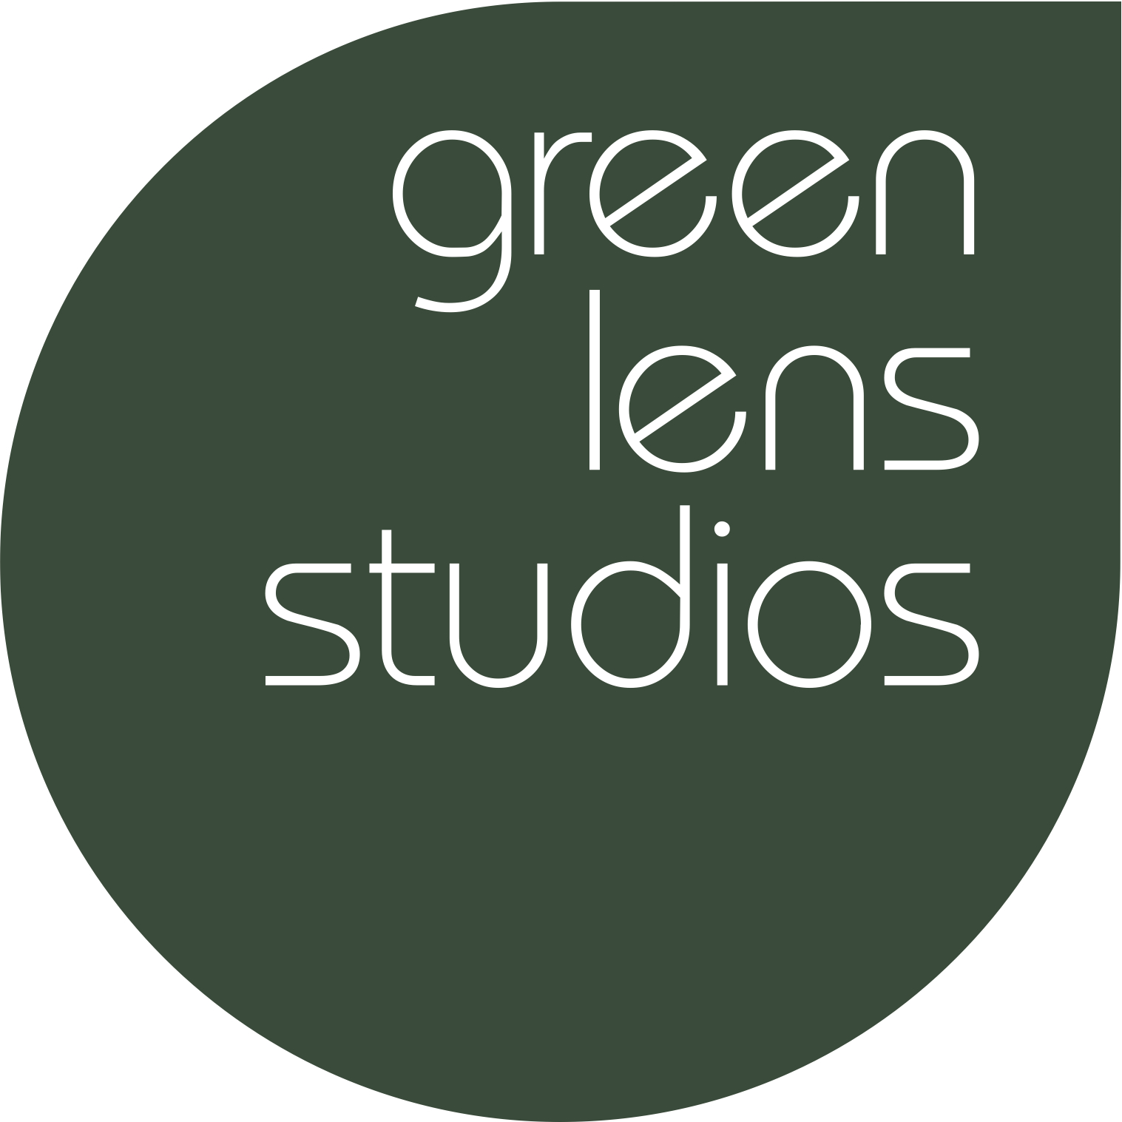
Contact Name: xx
Address: xx
Contact Number: Tel xx, mobile xx
Email Address: xx

Date(s) of Booking: xxth xx 20xx; 10am-6pm
Hire cost: £200 – 15% discount for charity
Equipment hire: colour gels, continuous lighting
Backdrop paper: n/a

To pay: £170 (50% pre-payment by February 9; 50% - by February 17)

By accepting this you also accept Green Lens Studios Terms and Conditions*.

Signature: ..............................................................................

Print Name: .............................................................................

Date: .............................................................................

To complete the booking please make the 50% pre-payment using the details provided.
NB Please use the reference quote provided when making a payment.

Beneficiary: Green Lens Studios
Bank: account: 21447268
Sort Code: 30-94-21
Reference: GLS_16xx

* Green Lens Studios Terms and Conditions

- Deposit is non-refundable
- The session time include set up and tear-down activities
- Please do not arrive more than 15 minutes before your session starts
- If you are overrun the agreed session times a charge of £30/hr will be applied
- Any damages will be charged at cost and are payable immediately
- If you are shooting moving image, you must notify us in advance

Please note: Green Lens Studios cannot be held liable or responsible for any event outside of its control that may affect your studio session – such as power cut, flooding, storm damage

